ALN (Additional Learning Needs)
The Welsh Government has passed legislation, called the Additional Learning Needs (Wales) Act, and Additional Learning Needs (ALN) Code, which will replace all of the legislation and guidance about special educational needs.

As part of the Additional Learning Needs Educational Tribunal (ALNET) (Wales) Act 2018 the Welsh Government has replaced the term ‘special educational needs’ (SEN) with ‘additional learning needs’ (ALN).

ALN will cover those who:

- have a significantly greater difficulty in learning than the majority of others of the same age

- have a disability which prevents or hinders them from making use of the educational facilities generally provided for others of the same age in mainstream maintained school or Further Education Institution.

There are four main areas of ALN:

Cognition and Learning

Sensory and Physical

Communication Interaction

Social, Emotional and Mental Health.

If you believe your child has ALN or is struggling in school please speak to your child's teacher or the School ALNco (Additional Learning Needs Coordinator) Mrs Hopkins.

We will listen to your concerns and we will gather all the information we need to decide if your child has ALN. This may include assessments, observations and/or referrals to specialist teams.

Within 7 weeks:

If your child does not have ALN but still needs extra support we will create a school support plan with you to detail the universal provision your child will access..

If your child does have ALN we will create an IDP - an individual development plan with you via a meeting called a PCP meeting- or a person centred practice meeting.

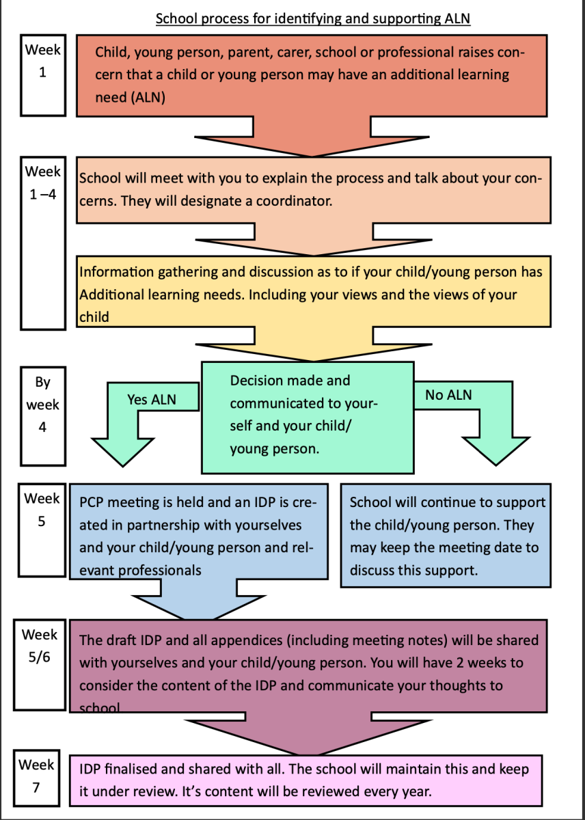

What if we don't agree?

If the school does not agree that your child has ALN, or you are dissatisfied with your child’s IDP, discuss it with the school or local authority.

If the local authority agrees with the school but you are still unhappy, they can point you to independent advocacy services.

All children and young people and their parents or carers have the right to appeal against decisions to the Education Tribunal of Wales (ETW).

A booklet is available to you in order to explain the new legislation, and how this will change the way that schools will work with you to identify and support your child’s needs.

Guidance Booklet for parents /carers

More information and useful videos can be found on the Vale of Glamorgan ALN page here:

https://www.valeofglamorgan.gov.uk/en/living/schools/Additional-Learning-Needs/Additional-Learning-Needs.aspx

ALN Check-ins

Mrs Hopkins holds ‘ALN check-in’ sessions on a Wednesday morning:
9.30-10.00am, 10.00am-10.30am, 10.30am - 11.00am, 11.00-11.30am.
These can be ‘in person’ in school or online via a ‘Google Meet’ link emailed to you.
If you would like to make an appointment for an ALN Check-in please speak to your child’s teacher, or inquire in the school office. (Please indicate if you want a google meet link or an in person meeting and which time you would prefer if available.)

Wellbeing Check-ins

Mrs Williams, our Wellbeing HLTA lead is available to speak to parents who may have concerns about their child’s wellbeing. This could be their emotional regulation, behaviour or anxieties. Mrs Williams is able to signpost parents to support available to parents. The Wellbeing Check-ins are available on a Monday Morning:
These appointments are ‘in person’ in school. Please speak to your child’s teacher or the school office staff to make an appointment.

Additional Services Available:

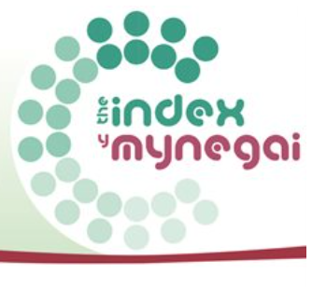

The Index for Children and Young People with Disabilities or Additional Needs

The Index is for families who have children age 0-18 years, who have a disability or additional need and live in the Vale of Glamorgan.
It’s a way of us keeping families informed about what’s available locally and nationally.

You’ll receive a newsletter every three months, packed full with information about events, activities, playschemes and services, as well as regular ebulletins. You can also contact us directly with any questions you have.

Sign up is free and completely voluntary and you don’t need to have a diagnosed disability.
There is more information on their web pages, as well as a quick video and an online registration form: www.valeofglamorgan.gov.uk/theindex
The Index video:
English https://www.youtube.com/watch?v=EX5nSx082PU
Welsh version https://www.youtube.com/watch?v=ArURUQW2JyM

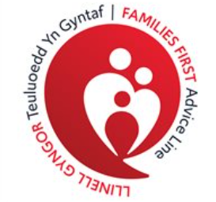
Families First Advice Line
Children, young people and their families sometimes need a little extra help.
The Families First Advice Line is the first point of contact for parents, carers and professionals who have, or are working with children age 0-18 residing in the Vale of Glamorgan.
The Families First Advisors offer a personal service with an aim of listening to and assessing the strengths and needs of each family. They offer information and advice to support families in resolving their difficulties independently and assist them in accessing other services to support them further if required.
Families First Advice Line aim to:
Listen to you and offer choices on how to meet your family’s needs
Support you in accessing the right help at the right time
If they are unable to answer your questions or resolve your concerns they will make every effort to identify a service that can.

- Monday to Friday: 9.00am – 4.30pm
- 0800 0327322
- familiesfirstadviceline@valeofglamorgan.gov.uk
- @FFALVALE
https://www.valeofglamorgan.gov.uk/en/living/social_care/children_and_young_people/families_first/Families-First-Advice-Line.aspx

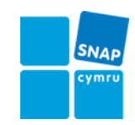

SNAP Cymru is a national charity, unique to Wales, founded in 1986. Its main aim is to advance the education of people in Wales and support their inclusion.
SNAP Cymru offers free and independent information, advice and support to help get the right education for children and young people with all kinds of special educational needs (SEN)/additional learning needs(ALN)and disabilities. We give advice and support on a range of issues including assessments, individual education plans, statements of special educational needs, bullying, school attendance, exclusion, health and social care provision and discrimination.
https://www.snapcymru.org/

